**CSS Basics**

**DEADLINE:** 12/04/2020

## **FOLDER STRUCTURE**

FL13_HW2/* **\*\* - required**

├─ task/** **\*\* - restricted (no need to submit)**

├─ examples/**

   └─ homework/*

        └─ css/*

            └─ bootstrap.min.css*

└─ general.css*

└─ style.css*

        └─ img/*

     └─ index.html*

## **TASK**

1) Open **index.html**. You are provided with a mark-up of a web-page, **print preview mode**[1] of which looks as follows (see **Figure 1**):



**Figure 1 — Print version**

Apply your custom CSS styles to modify the page print view. The result should look close (not pixel perfect) to the example provided in **Figure 2**.



##### **Figure 2 — Print version (mockup)**

2) Add a hover effect for the navigation items (background color – lightskyblue , text color - #fff). (see **Figure 2**).



**Figure 2 – Navigation hover effect(mockup).**

3) Add gradient from “lightskyblue” color to “burlywood “color for the banner.( see **Figure 3**)

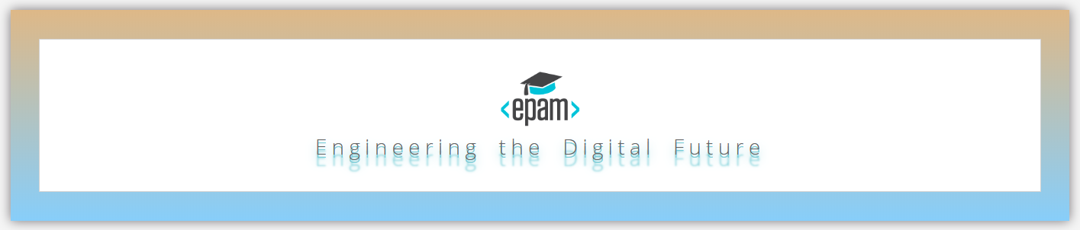**Figure 3 – Banner(mockup).**

4) Add shadow for banner text and spacing between words and letters. ( see **Figure 3**)

5) Add a box-shadow to navigation and to each content block (color - ***rgba(61, 55, 61, 0.7)***). Change banner’s background-color to ***#76cdd7***. Add text-shadow, letter-spacing and word-spacing to the banner (see **Figure 4** for reference).

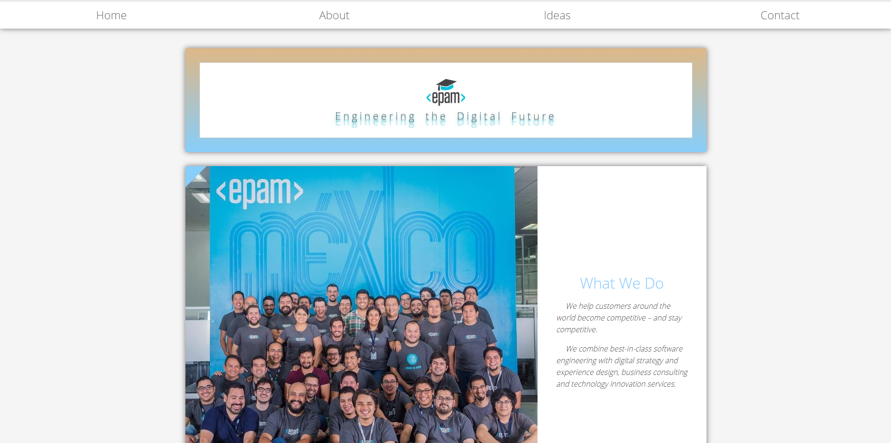

##### **Figure 4 — Blocks shadow and banner’s styling (mockup)**

6) Add animation to the banners text. Make it move from 45 degree to 0.

(see examples/animation.gif).

7) Add styles to make picture from the left side and text in center of section. Text should be styled as on the picture.(see **Figure 4**)

8) There is a gallery section in the markup. Please add a hover effect to it as shown in **Figure 5**.

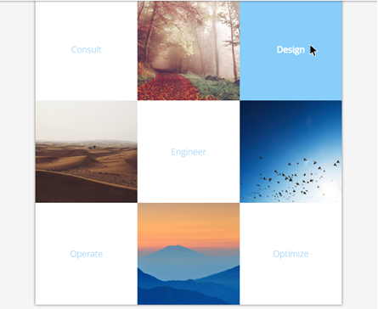

##### **Figure 5 — Gallery block (mockup)**

9) Make use of pseudo-elements to add a blue triangle to **each** section of the page (see top left corner in **Figure 6**).

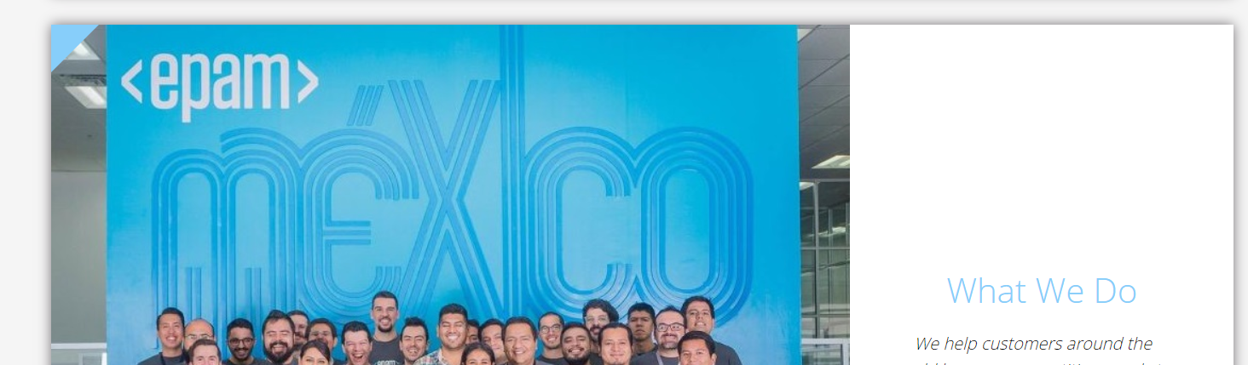

##### **Figure 6 —Triangle (mockup)**

10) Add styling to the “We are…” section (see **Figure 7** for reference):

* add styling to section header;
* change list type to **decimal-leading-zero**;
* the hovered links should look like “Architects” item (**red**);
* add “New” label to the end of “Designers” and “Strategists” list items; change their font-variant and boldness.

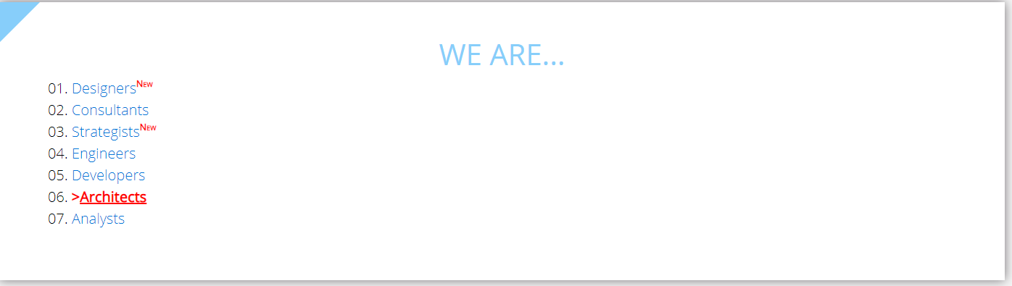

**Figure 7 —List styling (mockup)**

11)Every first paragraph that immediately follows <h2> should be italicized and formatted in such a way (see **Figure 8** for reference):

- vertical space between lines should be increased;

- some extra space at the start of the first line should be added.



**Figure 8 —Formated section (mockup)**

12) Style the following block as shown in **Figure 9**.

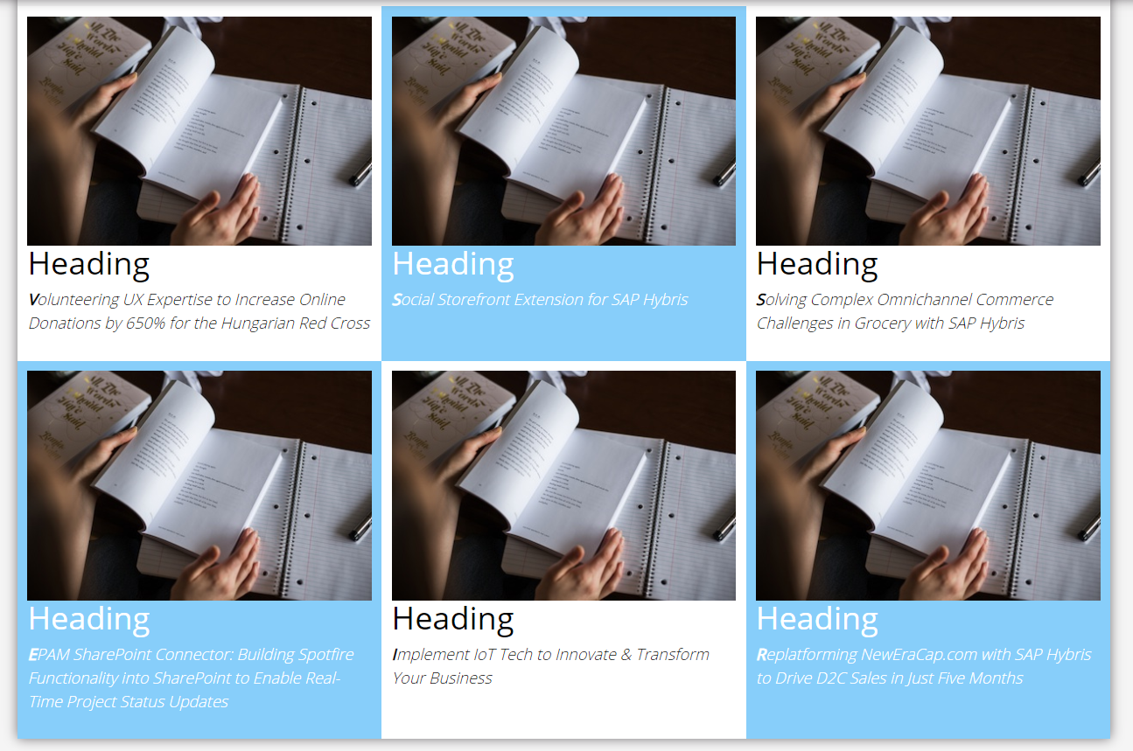

**Figure 9 —Block styling (mockup)**

13) Style form elements as shown in **Figure 10**. Note that subject field contains an image (img/search-icon.png).All fields have focus (Figure 11).

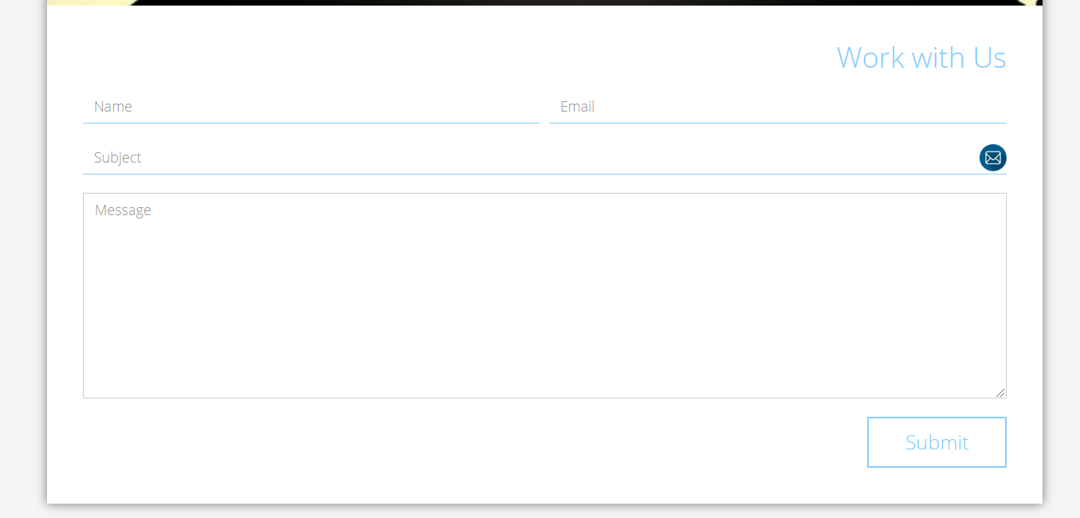

**Figure 10 —Work with Us form (mockup)**

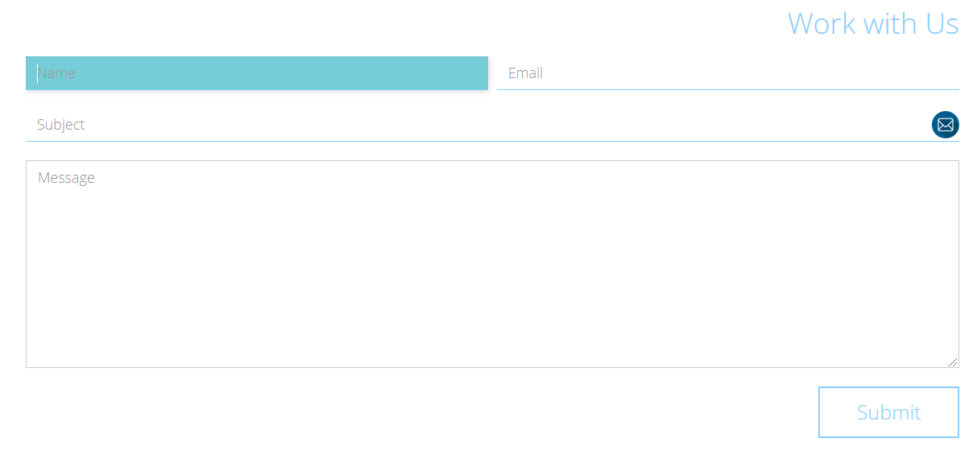

**Figure 11 —Work with Us form (mockup)**

The submit button should have a hover effect (see **Figure 12**).



**Figure 12 —Submit button in hover state (mockup)**

## **RESTRICTIONS**

* Adding/editing styles in the **general.css** and **bootstrap.min.css** file is forbidden;
* Usage of **JavaScript** is forbidden;
* Adding anything to **index.html** is forbidden;
* Adding **task/** and **example/** folders is forbidden. Do not push it to repository (only homework/ folder should be pushed);
* No requirements for browser support (should work properly in Google Chrome last version).

## **BEFORE SUBMIT**

* Read requirements and compare to your homework result;
* Format the code (remove unnecessary lines of code);
* Make sure your GitHub folder structure meets the required one (without **task** and **examples** folders);
* Validate your CSS (https://jigsaw.w3.org/css-validator/.

## **SUBMIT**

* The **FL13_HW2** folder should be uploaded to GitHub repository **“FL-13”** into **master** branch

## **USEFUL LINKS**

* <https://www.smashingmagazine.com/2007/07/css-specificity-things-you-should-know/>
* <https://dev.to/doppelmutzi/understand-how-css-styles-are-applied-to-html-elements-by-learning-the-fundamentals-precedence-specificity-cascade-de4>
* <http://specificity.keegan.st/>
* <https://vegibit.com/css-selectors-tutorial/>
* https://www.sitepoint.com/css-printer-friendly-pages/

1. To see **print preview mode**, open **index.html** file in a browser and press **ctrl+p** (or **cmd+P** for Mac).